**ASSIGNMENT 10.6**

**Problem Statement:**

* Write a pig script to find the minimum temperature observed in a given weather station in a particular year.
* Write a pig script to find the maximum temperature observed in a given weather station in a particular year.
* Write a pig script to find the number of readings given by each weather station according to the dataset.

**Input (Data set):**

The data set can be downloaded from the following link

<https://github.com/prateekATacadgild/DatasetsForCognizant/blob/master/Temperature.csv>

**Program:**

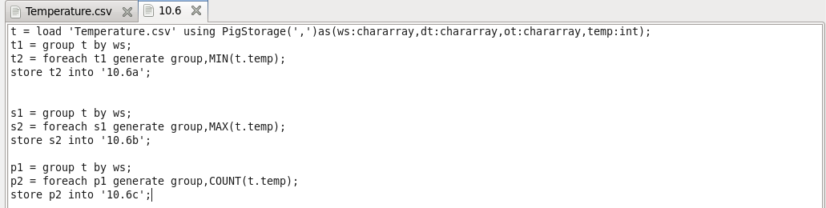

**Output:**

